Practical 9
Problem Definition
Implement secure user registration by inserting user details into MySQL using MYSQLi. Validate input on frontend and backend, check duplicate email/username, hash passwords using password_hash(), and display appropriate messages.
Code:-
Db.php:-
<?php
$host = "localhost";
$user = "root";
$password = "";
$database = "studenthub";

$conn = new mysqli($host, $user, $password, $database);

if ($conn->connect_error) {
die("Database connection failed.");
}

$conn->set_charset("utf8mb4");
?>
Register.php:-

<?php
require_once "db.php";

$message = "";
$messageType = "";

$username = "";
$email = "";

if ($_SERVER["REQUEST_METHOD"] === "POST") {

$username = trim($_POST["username"] ?? "");
$email = trim($_POST["email"] ?? "");
$password = $_POST["password"] ?? "";
$confirmPassword = $_POST["confirm_password"] ?? "";

if ($username === "" || $email === "" ||
$password === "" || $confirmPassword === "") {

$message = "All fields are required.";
$messageType = "error";

} elseif (!preg_match('/^[a-zA-Z0-9_]{3,30}$/', $username)) {

$message = "Username must be 3-30 characters using letters, numbers or underscore.";
$messageType = "error";

} elseif (!filter_var($email, FILTER_VALIDATE_EMAIL)) {

$message = "Please enter a valid email address.";
$messageType = "error";

} elseif (strlen($password) < 8) {

$message = "Password must contain at least 8 characters.";
$messageType = "error";

} elseif ($password !== $confirmPassword) {

$message = "Passwords do not match.";
$messageType = "error";

} else {

$check = $conn->prepare(
"SELECT user_id FROM users WHERE name = ? OR email = ?"
);

$check->bind_param("ss", $username, $email);
$check->execute();
$check->store_result();

if ($check->num_rows > 0) {

$message = "Username or email already exists.";
$messageType = "error";

} else {

$hashedPassword = password_hash($password, PASSWORD_DEFAULT);

$stmt = $conn->prepare(
"INSERT INTO users (name, email, password_hash)
VALUES (?, ?, ?)"
);

$stmt->bind_param("sss", $username, $email, $hashedPassword);

if ($stmt->execute()) {
$message = "Registration successful!";
$messageType = "success";
$username = "";
$email = "";
} else {
if ($stmt->errno === 1062) {
$message = "Username or email already exists.";
} else {
$message = "Registration failed. Please try again.";
}

$messageType = "error";
}

$stmt->close();

}

$check->close();
}
}
?>

<!DOCTYPE html>
<html lang="en">
<head>
<meta charset="UTF-8">
<meta name="viewport" content="width=device-width, initial-scale=1.0">
<title>Secure User Registration</title>
<link rel="stylesheet" href="style.css">
</head>
<body>

<div class="container">
<h2>User Registration</h2>

<?php if ($message !== ""): ?>
<p class="<?php echo htmlspecialchars($messageType); ?>"
role="status">
<?php echo htmlspecialchars($message); ?>
</p>
<?php endif; ?>

<form method="POST" action="register.php">

<label for="username">Username</label>
<input
type="text"
id="username"
name="username"
minlength="3"
maxlength="30"
pattern="[a-zA-Z0-9_]{3,30}"
value="<?php echo htmlspecialchars($username); ?>"
required
>

<label for="email">Email</label>
<input
type="email"
id="email"
name="email"
maxlength="100"
value="<?php echo htmlspecialchars($email); ?>"
required
>

<label for="password">Password</label>
<input
type="password"
id="password"
name="password"
minlength="8"
autocomplete="new-password"
required
>

<label for="confirm_password">Confirm Password</label>
<input
type="password"
id="confirm_password"
name="confirm_password"
minlength="8"
autocomplete="new-password"
required
>

<button type="submit">Register</button>
</form>
</div>

</body>
</html>
Style.css:-

* {
box-sizing: border-box;
}

body {
margin: 0;
font-family: Arial, sans-serif;
background: #eef2f7;
display: flex;
justify-content: center;
align-items: center;
min-height: 100vh;
}

.container {
background: white;
padding: 30px;
width: 90%;
max-width: 420px;
border-radius: 10px;
box-shadow: 0 4px 15px #0002;
}

h2 {
text-align: center;
color: #234b80;
}

label {
display: block;
margin-top: 15px;
font-weight: bold;
}

input {
width: 100%;
padding: 11px;
margin-top: 6px;
border: 1px solid #bbb;
border-radius: 5px;
}

input:focus {
outline: 2px solid #3976c5;
}

button {
width: 100%;
margin-top: 22px;
padding: 12px;
background: #234b80;
color: white;
border: none;
border-radius: 5px;
cursor: pointer;
}

button:hover {
background: #16365f;
}

.success {
color: #176b32;
background: #e4f6e8;
padding: 10px;
border-radius: 5px;
}

.error {
color: #a32020;
background: #fde8e8;
padding: 10px;
border-radius: 5px;
}

Screenshot:-
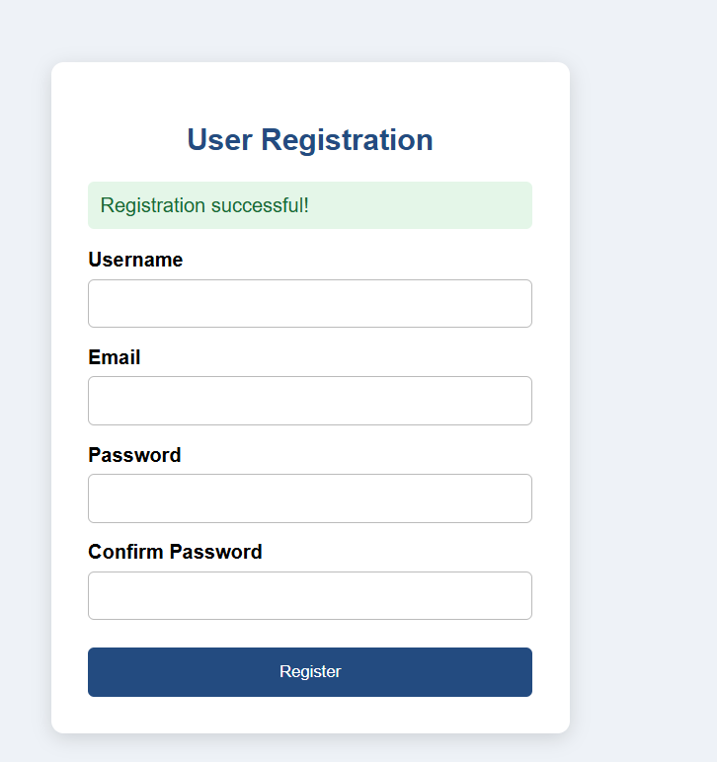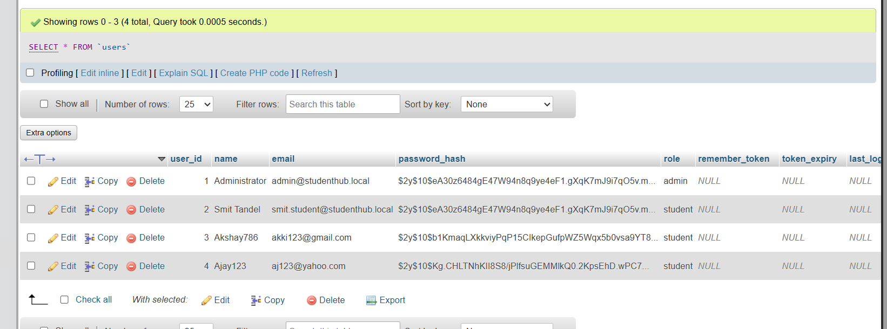
Key Questions / Analysis / Interpretation
1. Is password_hash() used before storing passwords?
Yes. The password_hash() function with PASSWORD_DEFAULT hashes the password before storing it in the MySQL database. This prevents storing passwords as plain text.
2. Is duplicate email/username checked?
Yes. A prepared SELECT query checks whether the username or email already exists in the database. The UNIQUE constraints on the database columns also prevent duplicate entries.
3. Are frontend and backend validations consistent?
Yes. Frontend validation uses HTML attributes such as required, minlength, maxlength, pattern, and type="email". Backend validation uses PHP functions such as trim(), preg_match(), and filter_var(). Both validate required fields, username format, email format, and password length. Backend validation is essential because frontend validation can be bypassed.

